1. Scenarios

**Scenario in Cucumber:**

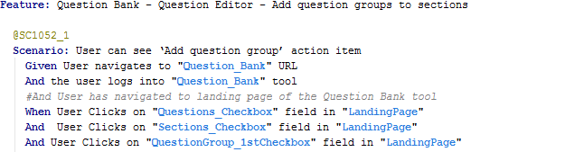

**Scenario in Jasmine:**

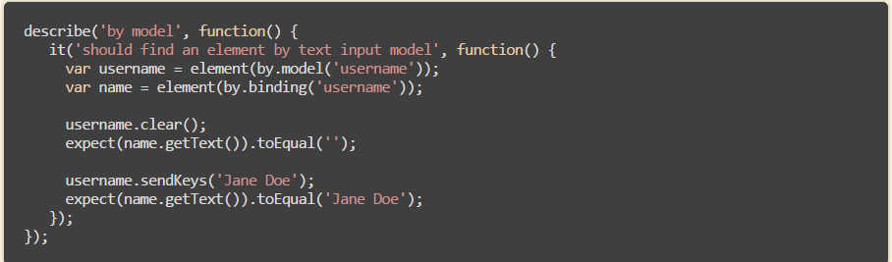

[WB]:

Step in Cucumber ‘Given User navigates to “Question_Bank” URL’, it is actually a function. In Jasmine, we can also define functions and put it in ‘describe’ or ‘it’ block.

The difference is that in Cucumber, users are forced to code like this, but in Jasmine, user is free to choose code the steps inside ‘it’ directly or replace them as a function like cucumber.

See below screen capture, I defined the description in ‘it’ block, which pretty much similar to cucumber feature file. It brings tester to the actual block of codes when alt+click on it. If we like, we can define all our reusable steps like this which provides the same feature as cucumber with a similar layout in jasmine test spec file and same output in report.

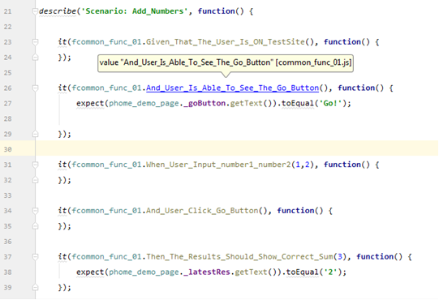

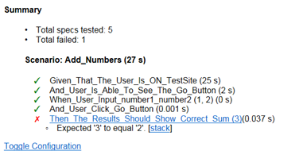

2. Step definition Reusability is not there in Jasmine. We can create a common step definitions and we can reuse these on all the feature files

[WB]: Both cucumber and jasmine support common step definitions and can be reused.

We can define either page level re-usable functions or action level re-usable functions in jasmine.

3. Jasmine is good for unit testing and Cucumber is Good for functional Testing

[WB]: regarding functional testing, hard to say which one is good, all depends on the way how they are coded.

4. Aligning the Gherkin script is easy in Cucumber using Feature file where as in Jasmine we cannot write Feature file

[WB]: Feature file is not necessary as an independent file, it can be incorporated into test spec file.

More files means more complicated in maintaining test scripts. Good to simplifier them.

5. Maintenance is very easy in Cucumber if any changes in requirement but it will be difficult in Jasmine because in Jasmine we need to update in all the step definitions

[WB]: Maintenance is not an issue for both cucumber and jasmine, it all depends on how test-developers code and whether follow best practice.

6. Cucumber feature file contains Plain English like statements so it will be very easy to understand for entire team ( BA,Dev,etc)

[WB]: ‘describe’, ‘it’ in jasmine is also plain English.

7. Easy to segregate the Automation scripts for executing based on the mentioned Tags in Cucumber. Example are Smote Scenarios, Regression scenarios etc. see @PE-1052 in the below code

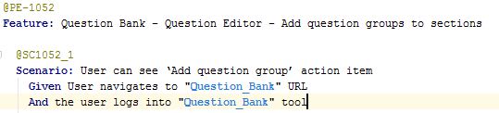

Whereas this feature is not available in Jasmine

[WB]: Jasmine provides ‘suite’ feature, which acts similar as ‘tag’ in cucumber, and ‘suite’ feature takes the advantage of providing an overview of tag definitions for easy maintain.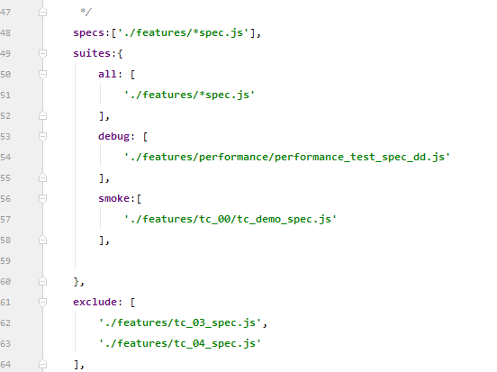

8. **Scenario outline:** Gherkin scripts can include data files in pipe delimited format. Here is an example

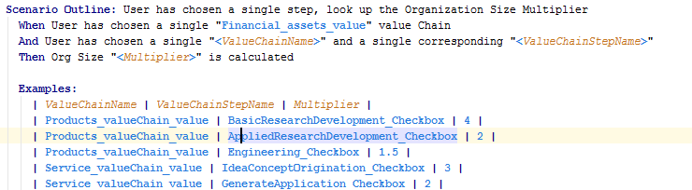

In this example the pipe- delimited data file will drive the AND and THEN line of the Gherkin script 5 times and will thus drive the scenario 5 times.

This we cannot achieve directly in the Jasmine.

[WB]: We can do the same thing in Jasmine, below sample shows a datadriven test with locally defined parameters and a single for loop make all of them run.

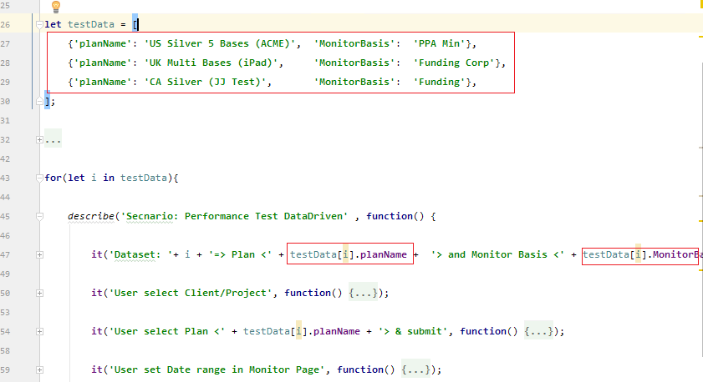

Below is this data driven output.

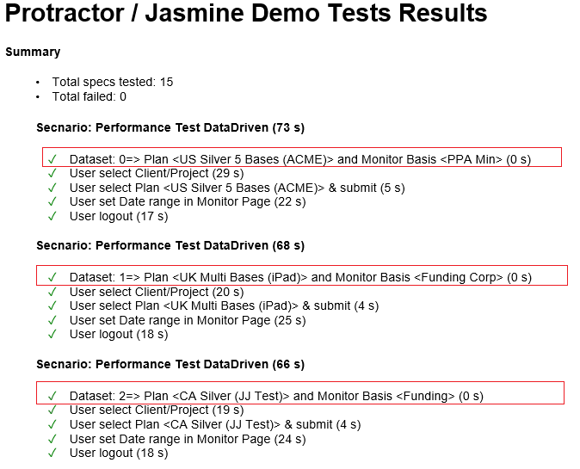

Also, we can use external jason file as data input to driven tests as well.

In below sample, defined external file “performance_test_date.jason” as datadriven input and used in test “performance_test_spec_external.js”, which acts as same as local defined data. But provides a clear structure with large set of input data if any.

